HOW TO LOG INTO CLUB LOCKER

  - Go to www.clublocker.com/admin
  - If you have a US Squash logon, enter your username and password
    - FORGOT PASSWORD? If you do not remember your username or password, click on the “Forgot Password?” link
    - NEW TO CLUB LOCKER/US SQUASH? If you do not have an account with US Squash, you can create a free account in seconds

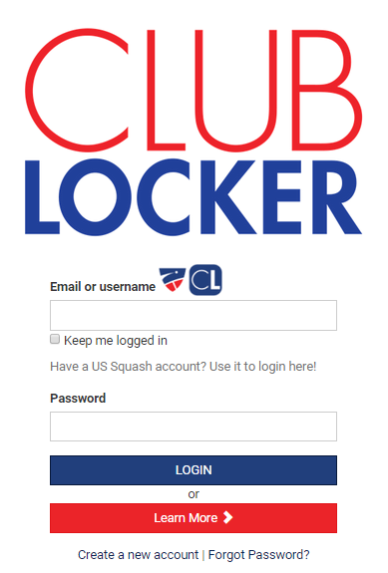

  - Once logged in, select the ‘Reservations: Club Admin’ Box
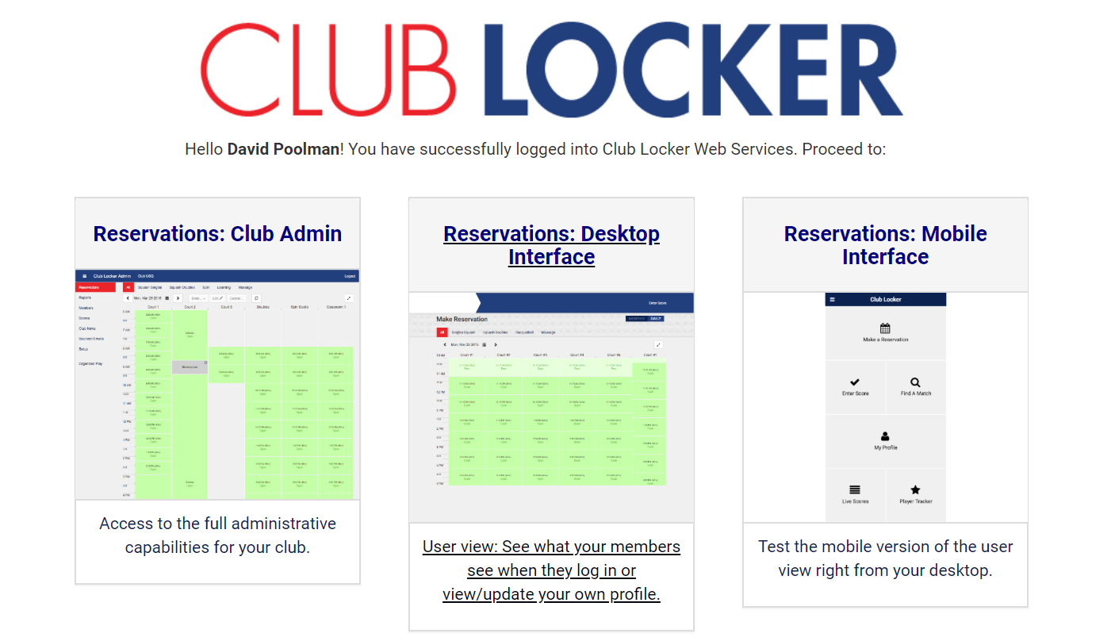

HOW TO CREATE A LADDER

- Select ‘Organized Play’ on the left side of the screen
- Select the ‘Ladders’ tab
- Select the ‘New’ button
- Fill out the form requiring name, dates rules…etc.
- Select the ‘Save’ button

HOW TO UTILIZE THE LADDER

- Select the green ‘Manage’ button to the right of ladder name
- To add a player, select +Add Player
  - Select ‘Search All’ tab
  - Type name in search field, preferably by last name first
  - Select name and ‘Add’
  - Select starting position in Ladder
- To input a challenge match result, select green ‘Add Score’ button
- To change ladder position, select the number link next to the name of the player whose position you are changing

c.
d.
.
b.

